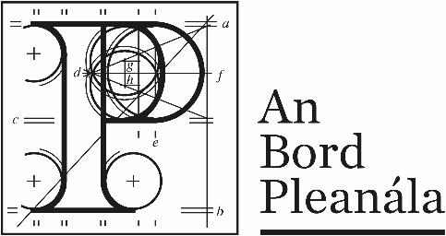
Documents received at Oral Hearing for
ABP-314232-22

Case Description | DART+ West Railway Order - Dublin City to Maynooth and M3 Parkway County Dublin, County Meath, County Kildare
Date | 12th October, 2023
Location | The Gresham Hotel, 23 O’Connell Street Upper, North City, Dublin, D01 C3W7

Documents received at Oral Hearing
No. | Submitted by | Presenter | Topic
 | Applicant |  | Update to Planning Report
 | Applicant |  | Response to suitability of the Depot location
 | Applicant |  | Depot Architecture Design Drawing
 | Applicant |  | Response to Carlos Clarke Ltd Submission
 | Applicant |  | Depot Drainage System Response

